### Introductory Biology BIOL 151 Fall 2022

### Lecture: M/W 2:30-3:45

##### ILC N151

### Contents

* Course Description 1
* Personnel 2
* Student Learning Objectives 3
* Required Materials 4
* Grading 5
* Academic honesty 6
* What will help you to be successful in this course 7
* Extra Help from the University 8
* Inclusive Learning in Biology 9
* Tentative Schedule 10
* Detailed topic list 11
* How to Sign Up For iClicker Reef 14

# Course Description:

In this first semester of college biology for life science majors you will begin by solving problems involving the basic biochemical units of life. From this we will move on to discussing cell to cell signaling, the cell cycle, and genetics. At all stages you will participate in problem solving, REEF questions and group discussions. The course is required for biology majors. (Gen.Ed. BS).

# Personnel

##### Instructor:

<PROF_FULL_NAME>

**Office:** Morrill II South Room 354

**Email:** <PROF_EMAIL>

#### Extra Help form the instructor:

**Office Hours** Check moodle

#### Course Personnel who can help you and when:

##### Graduate TAs:

<TA_FULL_NAME> <TA_EMAIL>

<TA_FULL_NAME> <TA_EMAIL>

<TA_FULL_NAME> <TA_EMAIL>

##### Supplemental Instructor: Undergraduate TAs:

|  |  |  |
| --- | --- | --- |
| <TA_FIRST_NAME> | <TA_LAST_NAME> | <TA_EMAIL> |
| <TA_FIRST_NAME> | <TA_LAST_NAME> | <TA_EMAIL> |
| <TA_FIRST_NAME> | <TA_LAST_NAME> | <TA_EMAIL> |
| <TA_FIRST_NAME> | <TA_LAST_NAME> | <TA_EMAIL> |
| <TA_FIRST_NAME> | <TA_LAST_NAME> | <TA_EMAIL> |
| <TA_FIRST_NAME> | <TA_LAST_NAME> | <TA_EMAIL> |
| <TA_FIRST_NAME> | <TA_LAST_NAME> | <TA_EMAIL> |
| <TA_FIRST_NAME> | <TA_LAST_NAME> | <TA_EMAIL> |
| <TA_FIRST_NAME> | <TA_LAST_NAME> | <TA_EMAIL> |
| <TA_FIRST_NAME> | <TA_LAST_NAME> | <TA_EMAIL> |

# Student Learning Objectives:

1. Illustrate through words and diagrams.
   1. How the structure and function of living organisms are derived from the properties of atoms and molecules.
   2. How phenotypes are derived interactions between genotypes and the environment
   3. How cells regulate and promote chemical reactions to communicate, divide, synthesize proteins, control gene expression, and capture and use energy
   4. How nothing in biology makes sense except in the light of evolution
2. Use model-based reasoning to solve problems by:
   1. Predict the consequences of changes to systems
   2. Infer system-states based on described conditions
   3. Apply quantitative principles
   4. Apply conceptual models to novel situations
3. Interpret standard graphical representations of data and biological processes such as figures, charts, tables, and diagrams
4. Become fluent in the language and conventions of the discipline
5. Demonstrate an understanding of biological systems by:
   1. Applying concepts to real life scenarios
   2. Connecting related ideas
   3. Explaining how biological processes are related to and interact with one another
   4. Recognizing patterns in biological systems
   5. Explaining how interactions of components in lower levels of organization contribute to complex properties of systems
   6. Comparing and contrasting structures and functions of biological systems in an evolutionary context
6. Apply lifelong learning skills by defining a problem and then locating, selecting, organizing information that can help you address that problem.

# Required Materials:

**Moodle:** moodle.umass.edu. **Check frequently.** Among other things you will find on moodle: required reading, homework questions, pre- lecture notes, post-lecture notes, recordings of every lecture, weekly quizzes, announcements, schedule changes, and your grades. **Did I mention that you should check frequently?**

**Reading:** There is no required textbook for this class. There will be reading/viewing each week there is no grade attached to these assignments. There will be an ungraded reading guide posted. This information will help you with exams. The assignments will consist of either posted PDFs from a free online textbook, or short videos for you to watch. The purpose of these assignments is to give you background information and help you to learn terms, I will **NOT** spend class time going over the same material, rather it will act as background.

**iClicker Cloud**: Clicker use is graded, but only for participation. If you answer 75% of the questions in a day, you get full credit for that class. You will need to register your clicker. Instructions for registering your clicker are appended to the end of this document. Clickers, or clicker cloud (which works on your phone), should be purchased through the textbook store. **Old versions of clicker will not work appropriately (please do not send an email asking if old versions will work).**. This is the only item you are required to purchase for the class.

**E-mail:** I know that it shows my age, but I like email. I will email you important changes, reminders and the like. You should check your email **at least daily**. **Not getting an email is not an excuse if the email was sent 24 hours in advance.**

**Discord:** Discord is a discussion forum that allows text, voice and video communication. It is free. In the context of this class you will use Discord to get answers to questions about the class and the content. You can also use it to collaborate with others in class on homework and quizzes. You can also use it to find people to study with. Finally you can use it DURING CLASS – to ask questions of me (<PROF_FIRST_NAME> that is). If you don’t want to raise your hand, you can just post your question to the “in class” questions channel.

* Find our class signup link on the top of the moodle page.

# Grading:

2 Exams 40 % (20% each)

1 Final Exam 24% Discussion problem sets 20% Wednesday Quizzes 15%

i> clicker cloud/REEF: 1% for attendance

Grade Scale A=93-100% A-=90-92.9%

B+=87-89.9 % B=83-86.9 % B-=80-82.9 % C+=77-79.9 %

C=73-76.9 % C-=70-72.9 % D+=67-69.9 % D=60-66.9 % F=0-59.9 %

**Examinations:** Two examinations will be held on 6 October and 10 November. A final exam will be held during finals period the date, time and room will be on spire. The two mid-term exams are not cumulative – you will be assessed on the material covered since the previous exam. However often there is material you need to know from the previous session. Mid-terms are Thursday evenings at 7 PM. They are designed to take 1 hour, but you are given 2 hours. If you need longer because of disability accommodations, you will need to contact me. If you have a conflict with another class’s exam we can provide an early exam IF the last digit of our spire number is HIGHER than theirs. **The final exam is cumulative**.

**Make‐up Exam Policy:** Students with a valid excuse for missing an exam must present it to me **before** the exam. If the excuse is valid and verified, I will drop that exam. Students may do this only once in a semester. An exam missed without a valid excuse will be recorded as a zero. A schedule conflict is not a valid reason for missing an exam.

**Exam Replacement:** If you score higher on the final exam than on one of your mid-term exams, the final exam score will replace that mid-term exam score. This is only true if you take both

* Exam 1: 75%
* Exam 2: 85%
* Final Exam: 90%

I will calculate your grade by replacing the 75% with a 90%

* Exam 1: ~~75%~~ ➔ 90%
* Exam 2: 85%
* Final Exam: 90%

This would raise the midterm average from 80% to 87.5%

##### Quizzes and homework:

**Quizzes** will be based on the lectures and homework in the week the quizzes are given. These will be multiple choice, True/False, matching and possibly some very short answer questions. They will be available on Moodle on Wednesday and you will have until Friday at midnight to complete them. Quizzes are open book and may be collaborative. You may not make them up, but the lowest one will be dropped. There will be a quiz help sessions run by our Tas after class and in the evening.

**Homework assignments** There will be a reading and/or a video to read or watch. In addition, there will be a reading guide that goes over what is important in the reading. Because this is ungraded, you have a choice whether to do it or not. However, I will not necessarily directly cover all of the concepts in the reading guide in class and you are responsible for them.

**Discussion sections:** The discussion sections reinforce what you learn in class and from the book. **They will begin the second week of classes and are required**. The discussion periods will include more active work as well as writing, calculations and some examination of data drawn from research papers. **Your group work in the discussion is graded**. At the end of every discussion there will be a graded assignment which you will have to work on **alone**. It will be either the same as or similar to the work you do with a group at the beginning of discussion and will be worth half of the discussion grade. If you must miss your discussion, make it up during one of the other sections (they are listed on moodle). However, you MUST make sure both your TA and the TA of the section you do the make up in, know that you are doing this.

**Clicker cloud/REEF grading**: One percent of your grade is for showing up and using your clicker. You will receive this credit for each day by answering 75% of a day’s questions using your clicker or the clicker cloud app. The first day is extra credit and I will drop four full classes in case you are sick or have an unavoidable conflict.

# Academic honesty:

**I will strictly follow the University’s academic honesty policy.** Using another’s words without citation, copying another’s answers (even with permission), or “helping” a friend by clicking in for him or her are all examples of academic dishonesty. They will at least earn you a 0 for the assignment, or potentially referral to the academic Dean.

* **What will help you to be successful in this**

**course**

These are quotes from actual students:

* Remember to take quizzes at the end of class so you don't forget to do them later in the week.
* Go to class, do the homework, use the practice exams they really help.
* Go to lecture, and don't just hide in the back and zone out. Pay attention, and think things through, because memorizing facts won't be enough to get a good grade.
* Attend class, save a chunk of time to study material each week, stay on top of work load, ask questions as much as possible, try to gain a basic understanding of chapter material before attending lecture/discussion for that chapter.
* I would advise them to go to all of the lectures and to pay close attention to the iClicker questions. I would suggest reviewing all of the questions asked in discussion quizzes, weekly quizzes, and homework quizzes before exams because they are a good indicator of what will be on the exam.
* Attend every lecture. Take notes on what <PROF_FIRST_NAME> says and less of whats on the slides (you can copy those later) he explains things in words really effectively and easy to understand. In discussion, make sure you don't sit back and let group members do the group quiz, ask your peers questions.
* If you find yourself tuning out in class or getting distracted, mark down when you tune back in and go watch the Echo recordings of when you weren't listening because you could've missed something important. Don't be afraid to ask questions in class, there's always someone else in the room who's thinking the same thing.
* Going to class is important, because the IClickers are very important for this class. If you do not go to class you will not get any reasoning behind the Iclickers or why the answer is what it is. <PROF_FIRST_NAME> wants you to be able to problem solve and think through problems, not just memorize and regurgitate material. I barely used my physical notes that I took in the class to study. Rather, I used the Iclicker questions on the power points, past discussion quizzes, weekly quizzes, and homework quizzes. The practice exams are posted every time before an exam, and they are super helpful. I definitely recommend doing them to learn what you need to work on and study. Additionally, I went to every single exam review session the night before the exams, and I highly recommend those as well. My SI/exam review teacher was super helpful, and put a lot of effort into developing a review session which covered almost everything that wound up being on the exam. Don't be afraid to ask
* Study as you go along. Cramming does NOT work.
* I think to get a good grade you have to know the material inside and out its not just memorization or knowing it slightly, you how to know how when and why and be able to answer any question given based on other questions that are similar. Also trying hard on the iclicker questions to see if you can get them is a big help when it comes to studying.
* The best way to study for this class is to review the clicker question, this is the only way

<PROF_LAST_NAME> class is taught. Everything is about the application of knowledge, you can't just simply memorize concepts and definitions.

# Extra Help from the University:

##### Disability Accommodation and Inclusive Learning Statement

If a student has a disability and requires accommodations, please let me know as soon as possible. You will need to register with Disability Services (161 Whitmore Administration building; phone 413-545- 0892). Information on services and materials for registering are also available on their website [www.umass.edu/disability.](http://www.umass.edu/disability)

Your success in this class is important to me. We all learn differently and bring different strengths and needs to the class. If there are aspects of the course that prevent you from learning or make you feel excluded, please let me know as soon as possible. Together we’ll develop strategies to meet both your needs and the requirements of the course. There are also a range of resources on campus, including:

* + •Writing Center - <http://www.umass.edu/writingcenter>
  + •Learning Resource Center - <http://www.umass.edu/lrc>
  + •Center for Counseling and Psychological Health (CCPH) <http://www.umass.edu/counseling>
  + •English as a Second Language (ESL) Program - <http://www.umass.edu/esl>

# Inclusive Learning in Biology

In this class we use the terms male and female to discuss sexual reproduction because that is the vernacular of the field. However, I understand that this does not necessarily represent the variation in gender identification among humans and that there is also diversity in sex and gender classification among diverse organisms.

# Tentative Schedule:

NOTE: There will be quizzes every Wednesday (due by Friday at midnight). There will be Moodle homework most weeks. There will be discussions every week with a few exceptions. **No discussions in weeks with holidays.**

Topics that will be covered in the order shown below and we will spend roughly a week on each topic.

1. The cell
2. Biological Molecules
3. Cell signaling
4. Cell cycle
5. Gene regulation
6. Transcription
7. Translation
8. Protein form
9. Protein trafficking/folding
10. Protein function
11. Energetics
12. Enzyme kinetics
13. Metabolism
14. Mendelian Genetics

# Detailed topic list

##### The Cell

* 1. Organization
  2. membranes

##### Biomolecules

* 1. Four types
  2. Hydrophobicity
  3. Recognizing structures

##### Cell signaling

* 1. Using models to understand a system
     1. Kinases phosphatases
  2. Amplification and feedback loops
  3. Terminating/modifying signaling

##### Control of cell division

* 1. Cell cycle
     1. Stages of mitosis (in discussion)
     2. Cyclins and CDKs
        1. Protein electrophoresis
     3. Checkpoints
     4. Chromosome nomenclature (homologs, chromatids)
     5. Regulation of SAC
  2. cancer biology
     1. Oncogenes and tumor suppressors
     2. Genetic instability

##### Transcription

* 1. Central dogma
  2. 5’ to 3’ structurally and functionally
  3. DNA chemistry and structure
  4. The mechanics of transcription
  5. DNA electrophoresis
  6. RNA processing
  7. Differences in pro/euk

##### Translation

* 1. Differences in pro/eukaryotic
  2. Ribosome and tRNA
  3. N and C termini of proteins
  4. Reading frame amino acids
  5. mutations

##### Control of gene expression/epigenetics

* 1. Levels of expression control
     1. Transcriptional, translational, post-translational
  2. DNA packaging and epigenetics
     1. Methylation and acetylation
  3. Transcriptional control
     1. repressors , inducers, promoters, enhancer, activators, operons
  4. The lac operon

##### folding/trafficking

* 1. Levels of protein structure
     1. Characteristics of alpha/beta structure
  2. How amino acid properties affect folding
     1. Hydrogen bonding
     2. Temperature sensitive mutations
  3. Chaperones
  4. Protein trafficking
     1. Through this cell structure in ppro and eukaryotes
     2. ER and the concept of toplogical equivalence
     3. Co-translational import
     4. Vesicle trafficking

##### energetics/enzymes

* 1. Gibbs free energy and the laws of thermodynamics
     1. exergonic/endergonic
  2. Energy transfer molecules
     1. Redox reactions
     2. Energetic coupling
  3. Enzymes
     1. Kinetics (shape of M&M without math
        1. Two forms rate vs. [] and product vs. time
        2. Km and Vmax
     2. What an enzyme can do and can’t do
     3. Inhibition and affect on km vmax

##### Metabolism

* 1. Conceptual coupling of photosynth and resp
     1. CO2 H20 and O2
  2. Morphology of c’plast and mito -- membranes
  3. Glycolysis
     1. Anabolic catabolic
     2. TCA
  4. Products and inputs
     1. Following CO2 and O2

##### Electron Transport Chain

* 1. Electron donors and acceptors
  2. PMF
  3. ATPase
  4. Inhibition understand process

##### Genetics

* 1. Meiosis and ploidy
  2. Crossing over
  3. Simple mendelian crosses up to dihybrid and a little sex linkage
     1. Dominance and its molecular underpinnings
  4. How alleles phenotypes genes and proteins are related
  5. Pedigree problems

# How to Sign Up For iClicker Reef:

## Getting credit for clickers in Bio151

Go to this web site: https://app.reef- education.com/#/login

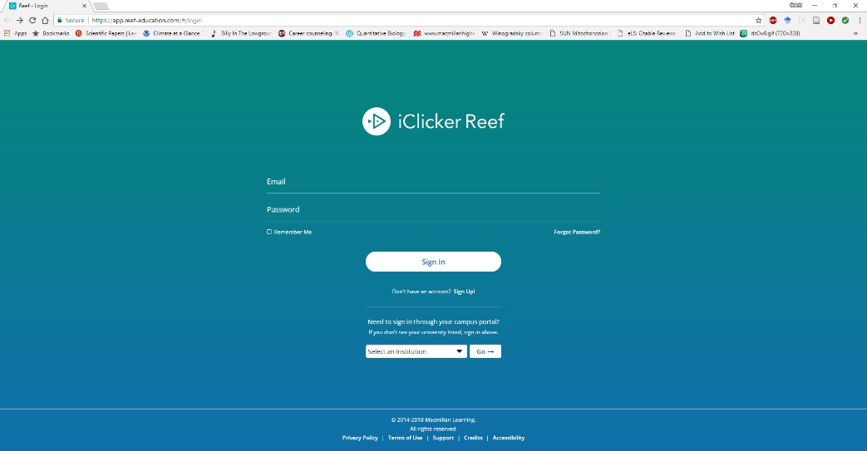

Click sign up

Find your school (hint: UMass)

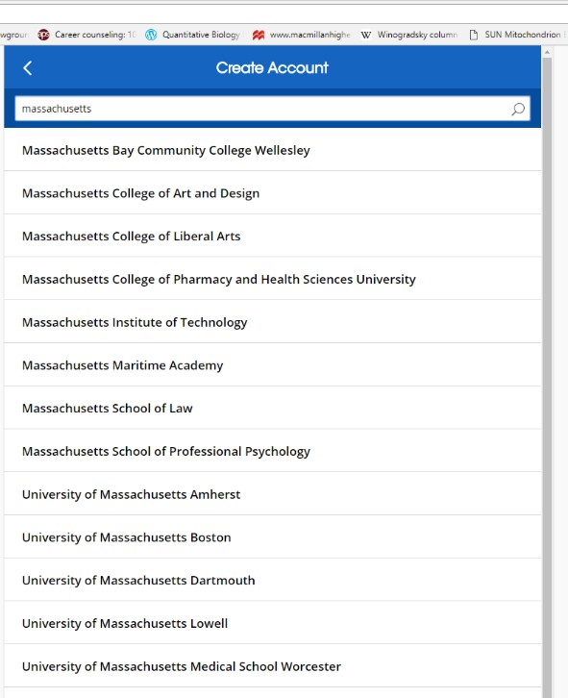

In that next screen tell them about yourself. What’s your favorite color? Do you enjoy long walks on the beach? **Better yet tell them your name, @umass student email and student ID.**

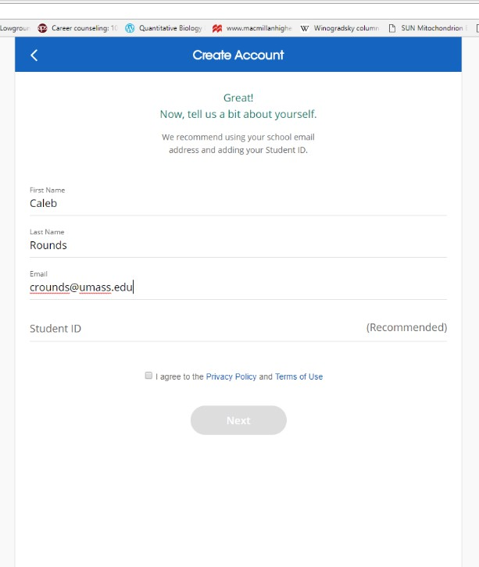

Agree to the privacy policy.

Create a password you can remember, that conforms to their guidelines.

Sign in. Register your remote by typing in the serial number on the back (8 digits):

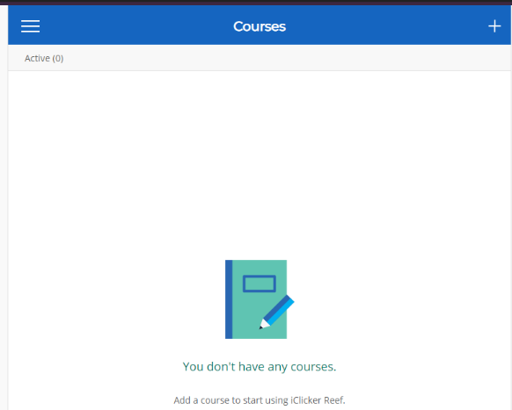

BTW, the code at right is for a broken remote that I have in my office

Add a course by clicking the plus symbol in the upper right-hand corner.

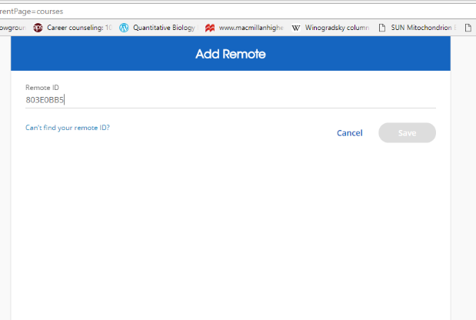

Click where it says “university of Massachusetts Amherst”

Type in <PROF_LAST_NAME> and pick Bio151 F22 <PROF_LAST_NAME>

Make sure you select this semester’s course (Hint: Fall 2022) Add the course.

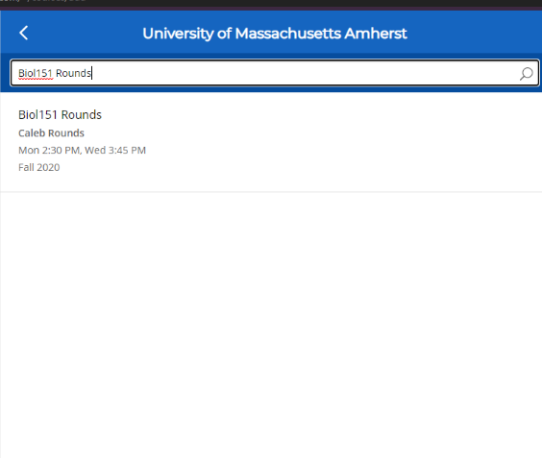

Now you are registered.

You can install REEF on your phone or log into the class on your computer. Generally if you have zoom open on your computer it will be easier to use your phone for zoom. But if you only have one device, you can have them both on one device.